|  |  |  |  |  |  |  |  |  |
| --- | --- | --- | --- | --- | --- | --- | --- | --- |
| **-11-0** |  |  |  |  |  |  | + |  |
| **01--0** |  |  | + |  |  |  | + |  |
| **-1-0-** |  |  | + |  |  | + | + | + |
| **--10-** |  | + |  |  | + |  | + |  |
| **0--0-** | + | + | + |  | + | + | + |  |
| **---00** | + | + | + | + |  |  | + | + |
|  | 00000 | 00100 | 01000 | 10000 | 00101 | 01001 | 01100 | 11000 |

|  |  |  |  |  |  |  |
| --- | --- | --- | --- | --- | --- | --- |
|  |  | + |  | + |  | **-11-0** |
|  |  | + |  |  |  | **01--0** |
|  | + |  | + | + | + | **-1-0-** |
| + | + |  |  | + | + | **--10-** |
|  | + |  |  |  |  | **0--0-** |
| + |  |  |  | + |  | **---00** |
| 10100 | 01101 | 01110 | 11001 | 11100 | 11101 |  |



|  |  |  |  |  |  |  |  |  |  |  |  |
| --- | --- | --- | --- | --- | --- | --- | --- | --- | --- | --- | --- |
|  |  |  |  |  |  |  |  |  |  |  |  |
|  | 0 | 0 | 1 | 0 | 1 | 0 | 0 | 0 | 0 | 1 | **1** |
|  | 0 | 0 | 1 | 0 | 0 | 0 | 0 | 1 | 0 | 0 | 0 |
|  | 0 | 0 | 0 | 0 | 1 | 0 | 0 | 1 | 0 | 0 | 0 |
|  | 0 | 0 | 0 | 0 | 0 | 0 | 0 | 1 | 0 | 1 | 0 |
|  | 0 | 0 | **1** | 0 | 0 | 0 | 0 | 0 | 0 | **1** | 0 |

|  |  |  |  |  |  |  |
| --- | --- | --- | --- | --- | --- | --- |
|  |  |  |  |  |  |  |
|  | + | + | + | + | **1** | **1** |
|  | 0 | **1** | **1** | 0 | 0 | 0 |
|  | **1** | 0 | 0 | **1** | 0 | 0 |

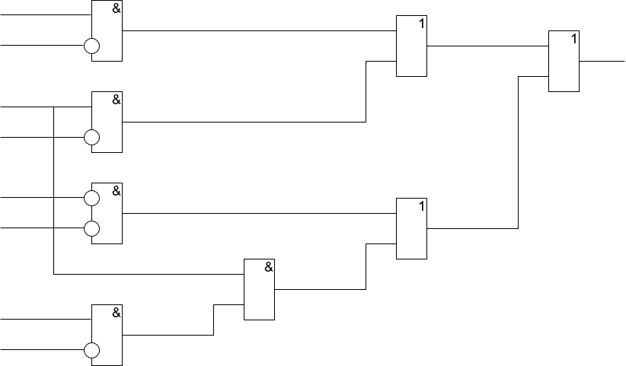

// неполная ДНФ

u2 = x2 and !x4;

u3 = x3 and !x4;

u4 = !x4 and !x5;

z1 = x2 and !x5;

u1 = x3 and z1;

v1 = u2 or u3;

v2 = u1 or u4;

f = v1 or v2;

printf(f ? " 1 " : " 0 ");

